IT System Security & Physical Security Lab

Exercise -5

Name: Divyam Kumar

SAPID: 500083141

Batch: B2

Q1. Perform this Experiment to search sensitive / interesting information on the Internet using mentioned Google Operators and GHDB and mention steps/screenshots.

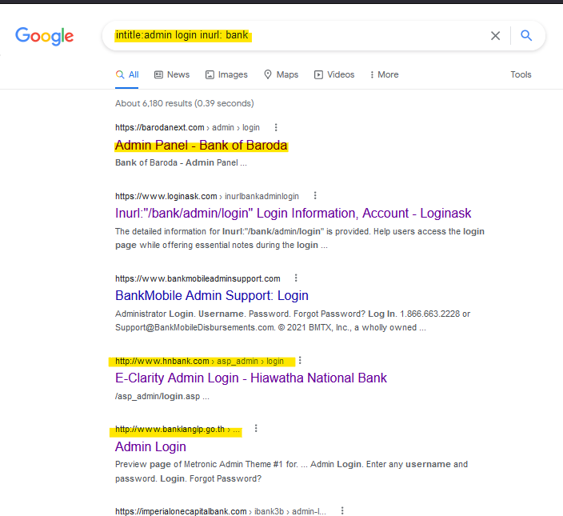1.

I found admin login pages of different banks.

2.

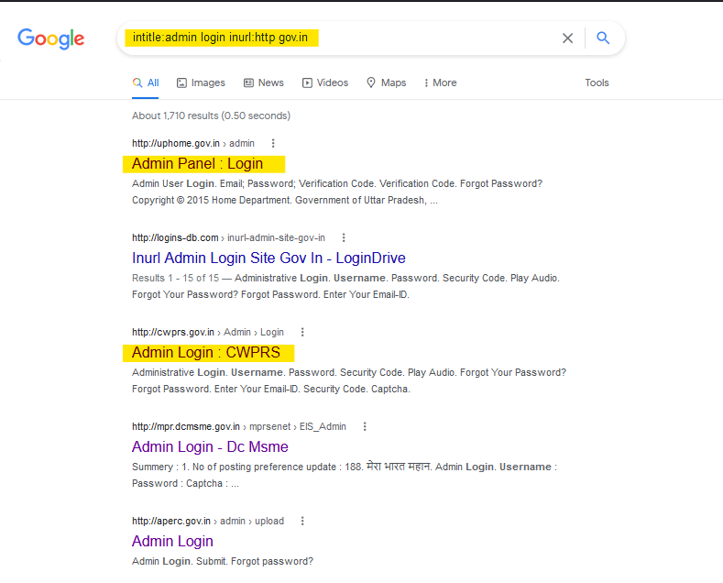I found admin login pages of various government sites.

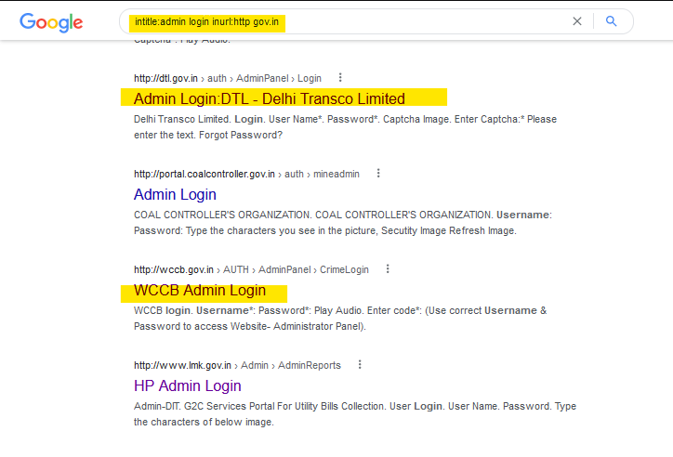

3.

I found an excel containing contact information like email, mobile no, and fax.

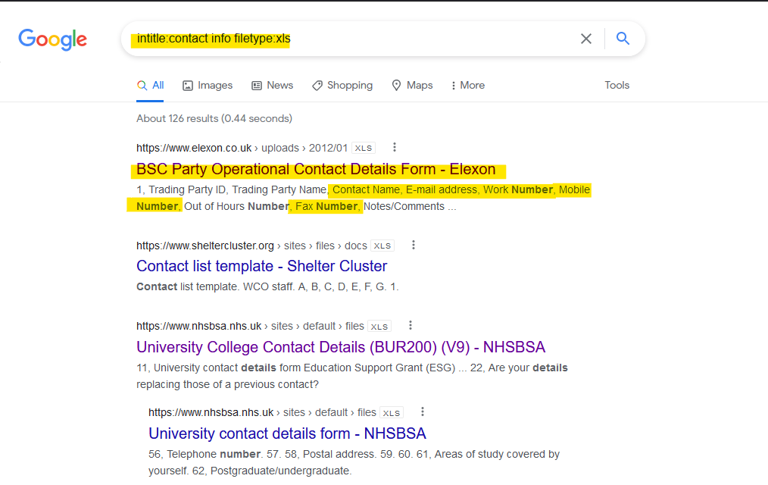

4.

I found some PDF files on UFO sightings.

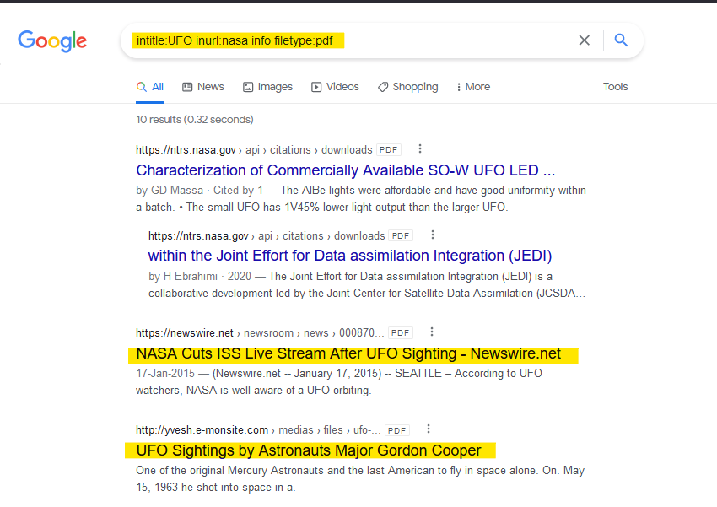

5.

I found a document containing information on hidden portals on earth.

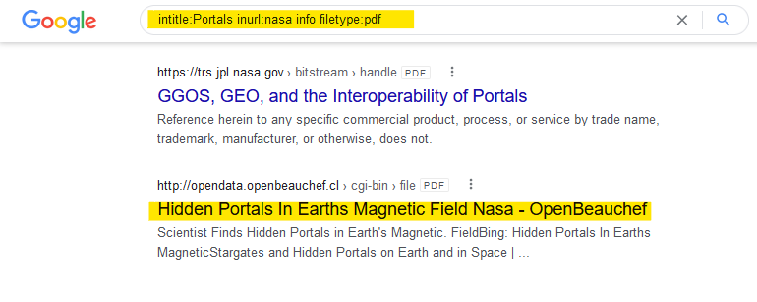

6.

Found an exploit on GHBD through which I was got login portals of several sites.

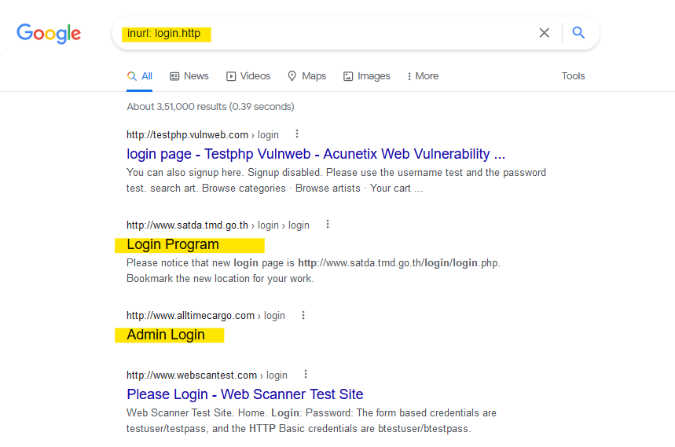

7.

Found this exploit on GHDB, it showed many login portals of ‘Amcrest’ devices.

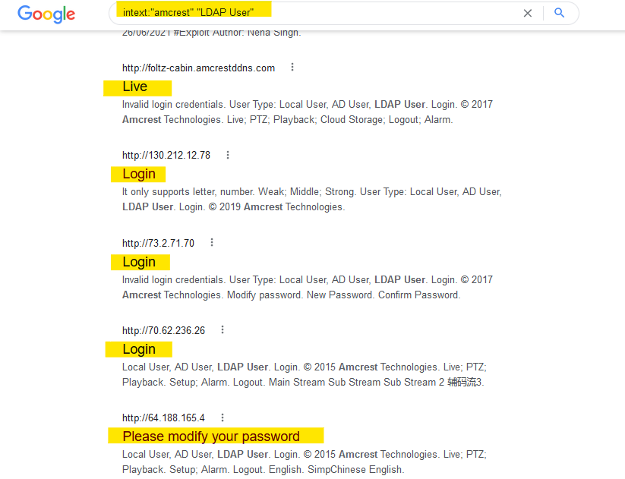

8.

This exploit on GHDB gave me access to control menu of various IP cameras.

